WRITING LIVES IN EUROPE 1500-1700
A conference to be held at University College Dublin 6-8 September 2018
(supported by the College of Arts and Humanities and the Humanities Institute, UCD)
#writinglivesUCD

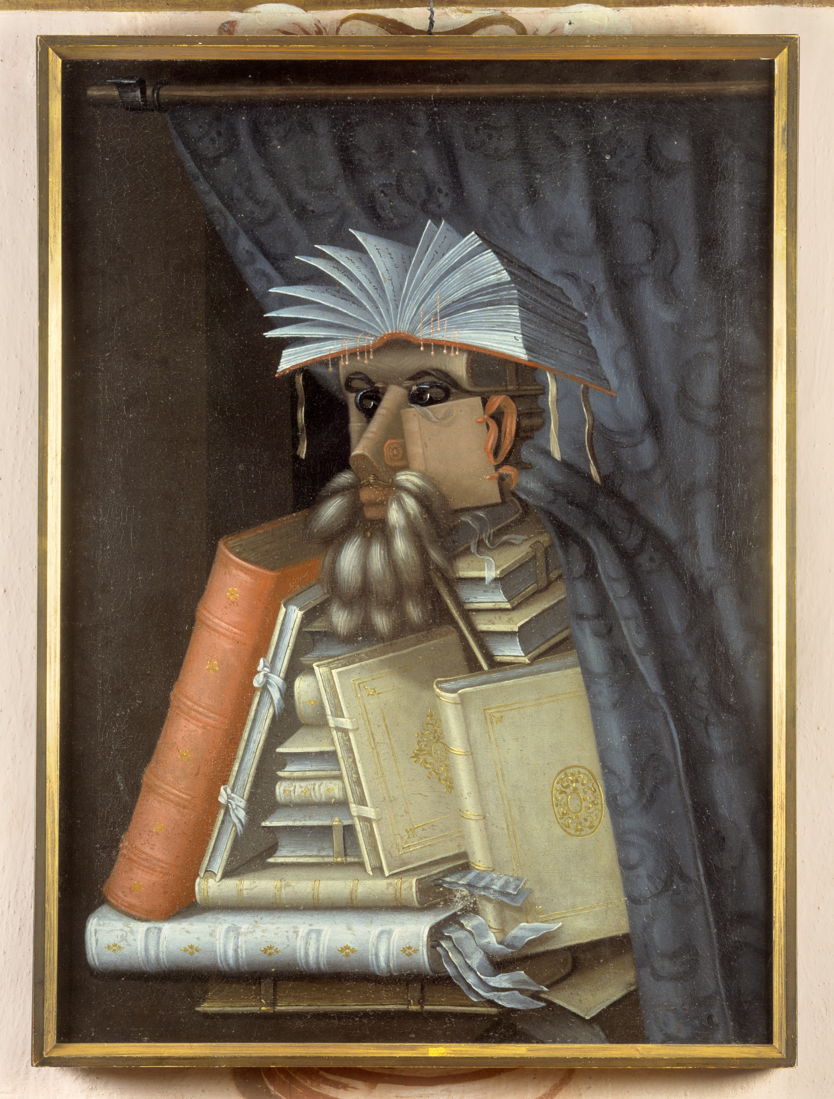
'The Librarian' Giuseppe Arcimboldo, c.1566 (Skokloster Castle)

Thursday 6th September 2018, Humanities Institute, UCD

9-9.30 Registration and coffee
9.30-11 Plenary I: Prof Andrew Hadfield (Sussex), Reading The Life Between the Lines: Nashe, Spenser and Others
11-11.30 Coffee
11.30-12.30 Panel 1: The Religious Self
Richard Kirwan (UL) “Trouble Every Day: Experiences of Religious Exile in the Writings of Jacob Reihing”
John McCafferty (UCD) '"O Felix Columba Caeli/ O Happy Dove of Heaven": a manuscript life shredded by early modern print'
12.30-1.30 Lunch (food trucks, Sutherland School of Law, UCD)
1.30—2.30 Panel 2: Unmooring life-writing: method, memory, and genre
Chair: Prof Kate Chedgzoy (Newcastle)
Ramona Wray (QUB), “Reading Life-Writing in the Cary/Tanfield Record”
Kate Hodgkin (U of East London), “Memory, melancholy and the languages of loss in 17th century life writing”

2.30-3 Break
3-4.15 Panel 3: – Life writing and religion
Ann-Maria Walsh (UCD) “Mary (née Boyle) Rich, Countess of Warwick (1624-1678): Writing and Experimenting – A Spiritual Life”
Mark Empey (NUIG) “Life writer and Life writing: the parallel worlds of Sir James Ware”
5 Wine reception – Common Room, Newman Building, UCD

Friday 7th September 2018, K114, Newman Building, UCD

9.30-11 Plenary II: Prof Kate Chedgzoy (Newcastle), Writing Children’s Lives
11-11.30 Coffee
11.30-1 Panel 4 – Women in the 17th Century
Carol Baxter (independent scholar) “’Serving God rather than my father’: religious life writing as a rejection of the patriarchal family”
Naomi McAreavey (UCD) – The Countess of Ormonde’s Letters (title tbc)
Danielle Clarke (UCD) “Irish women’s recipe books as life writing: form, process, method”

1-2 Lunch (exhibition and archive visit)
2-3 Panel 5 – Travel and formation of the self
Maria Luis Dominguez-Guerrero (Seville) “Rhetoric of the Conquest: Narrations from Castilian Explorers”
Eva Holmberg (Helsinki) “Visual Self-Description in Seventeenth-Century British Travel Accounts”
4-6 Walking tour of Renaissance Dublin (AM Walsh), followed by pub visit and conference dinner, at Le Pichet, Trinity Street, Dublin 2*
Saturday 8th September 2018, K114, Newman Building
9.30-11 Plenary III: Prof Alan Stewart (Columbia), Writing Lives under Duress
11-11.15 Coffee
11.15-1 Panel 6 - Alternative Forms
Nelson Marques (Miami) “War and Self: Soldier’s Petitions in Seventeenth-Century Portugal”
Emma Claussen (Oxford) “Forms of living in Descartes’s Les passions de l’âme”
Raluca Duna (Bucharest) “Writing the self with images, painting identity with texts”
1-1.30 Roundtable and close

Followed by optional lunch at Avalon, Donnybrook, Dublin 4

* Dinner is €40 per head. Wine will be supplied!

Conference information:

- The conference is free to attend, but for catering purposes we would appreciate it if you could sign up using this link: https://www.eventbrite.com/e/writing-lives-1500-1700-tickets-48653964317
- All sessions will take place on the UCD campus, details of which you can access here http://map.ucdestates.ie/
- UCD is on many direct bus routes from the city centre (39/39a, 46a, etc); the Aircoach (stops outside T1 and T2 at Dublin airport) also stops outside. Full details are here http://ucdestates.ie/commuting/
- There are numerous accommodation options nearby, or on direct transport links: the Mespil hotel, Leeson Bridge B&B, Shanahans on the Green, Radisson Blu, St Helen’s – Air BnB will also have a wide range of differently priced options.

If you have any questions, please email us at writinglives@ucd.ie. We look forward to meeting you in September!

Danielle & John

